Office of the Provost and Vice President for Academic Affairs
516 High St., Bellingham, WA 98225-9033
p (360) 650-3480 • f (360) 650-7475
www.wwu.edu
May 13, 2020

Steve VanderStaay, Vice Provost for Academic Affairs

Dear Steve,

First, thank you very much for all your work on Western’s Incident Command Structure (ICS) associated with the COVID-19 health crisis. Your insight and wisdom have certainly been a boon to that structure and to our ability to navigate these uncertain times.

Related to that work, you recently met with Associate Vice President Brian Burton and me to discuss how we might approach First-Year-Experience planning for Fall Quarter 2020. I write in follow-up.

Please proceed to convene a planning group that will undertake the work associated with ensuring a positive, productive, engaging, and effective first-year experience for students entering Western in Fall Quarter of 2020. When we discussed this initially we outlined a number of important elements of this planning, but please know that you and the group should feel free to consider any and all issues associated with the unique challenges that Fall 2020 presents for first-year experience. If the work of the group could be delivered prior to May 22, 2020, it would be optimal, but I acknowledge the tight timeline and would understand if the work requires more time. This group will operate outside the ICS and this letter will serve as my charge to the group once and as convened.

Sincerely,

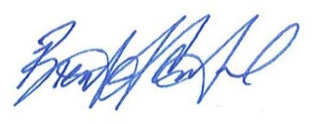
Brent Carbajal
Provost and Vice President for Academic Affairs
Western Washington University

